FML U4 REMAINING TOPICS
Artificial Neural Network (ANN) — Detailed Notes

1. Definition
- An Artificial Neural Network (ANN) is a computational model inspired by the structure and function of the human brain, made up of interconnected units called neurons.
- Each neuron receives numeric inputs, multiplies them by weights, adds a bias, applies an activation function, and passes the result onward.
- ANNs learn by adjusting their weights and biases using data, so they can map inputs to desired outputs.

2. Basic Structure and Working

- A typical ANN has three kinds of layers: an input layer, one or more hidden layers, and an output layer.
- In the forward pass, input data flows from the input layer through hidden layers to the output layer to produce a prediction.
- The network computes a loss (error) by comparing predictions with true targets, and then adjusts weights using backpropagation and an optimization algorithm.
- Backpropagation computes gradients of the loss with respect to each weight using the chain rule, and the optimizer updates weights to reduce the loss.

3. Types of ANN (with short description and use-cases)
- Feedforward Neural Network (FNN):
Every neuron in each layer connects only to neurons in the next layer, and there are no cycles. FNNs are used for simple pattern mapping and basic classification or regression tasks.
- Multilayer Perceptron (MLP):
An MLP is a feedforward network with one or more hidden layers and nonlinear activation functions. It is a universal function approximator and is commonly used for tabular data classification and regression.
- Convolutional Neural Network (CNN):
CNNs use convolutional layers that apply small filters across spatial dimensions of input (e.g., images) to detect local patterns. They are widely used for image recognition, object detection, and video analysis.
- Recurrent Neural Network (RNN):
RNNs have connections that form cycles, allowing the network to keep internal state; this makes them suitable for sequence data such as text or time series.

4. Applications of ANN (detailed examples)
- Image Recognition and Computer Vision:
CNNs detect objects, classify images, and segment images for tasks such as medical imaging (e.g., tumor detection), autonomous driving (e.g., pedestrian detection), and face recognition.
- Speech Recognition and Audio Processing:
RNNs or specialized architectures convert spoken audio into text, power voice assistants, and perform speaker identification.
- Natural Language Processing (NLP):
ANNs power sentiment analysis, machine translation, text summarization, question answering systems, and chatbots. Transformer-based neural networks are a specialized ANN family used heavily in NLP.
- Time Series Forecasting:
RNNs, LSTMs, and sequence models predict stock prices, weather, and demand forecasting by learning temporal dependencies.
- Healthcare and Medical Diagnosis:
ANNs analyze medical images, predict disease risk from patient data, and assist in diagnosis by learning patterns from historical data.
- Recommendation Systems:
Neural networks learn user-item interactions to suggest relevant products, movies, or content to users.
- Anomaly Detection and Fraud Detection:
Autoencoders and classification networks detect unusual patterns in transactions, logs, or sensor data.
- Generative Tasks:
GANs and variational autoencoders create realistic images, deepfake media, or synthetic data for training and simulation.

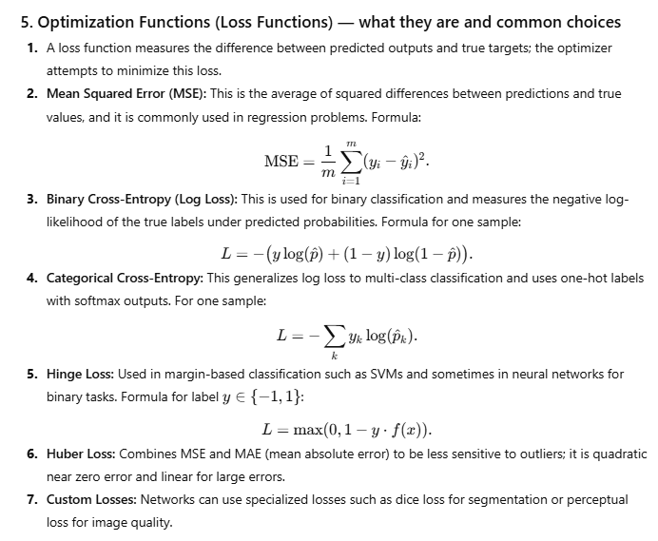

6. Common Optimization Algorithms (short, exam-style)
- Gradient Descent (Batch): Computes gradient using entire dataset and updates weights; simple but slow for large data.
- Stochastic Gradient Descent (SGD): Updates weights per training example; faster and adds noise that can help escape local minima.
- Mini-batch SGD: A compromise that updates weights using small batches of data and is the most commonly used in practice.
- Momentum: Improves SGD by adding a fraction of the previous update to the current update to accelerate convergence.
- AdaGrad: Adapts the learning rate per parameter, giving smaller updates for frequently occurring features.
- RMSProp: Fixes AdaGrad’s aggressive decay by using an exponential moving average of squared gradients.
- Adam (Adaptive Moment Estimation): Combines momentum and RMSProp; it maintains running averages of gradients and squared gradients and generally works well as a default optimizer.
- AdamW, Nadam, etc.: Variants that address weight decay regularization or use Nesterov momentum.

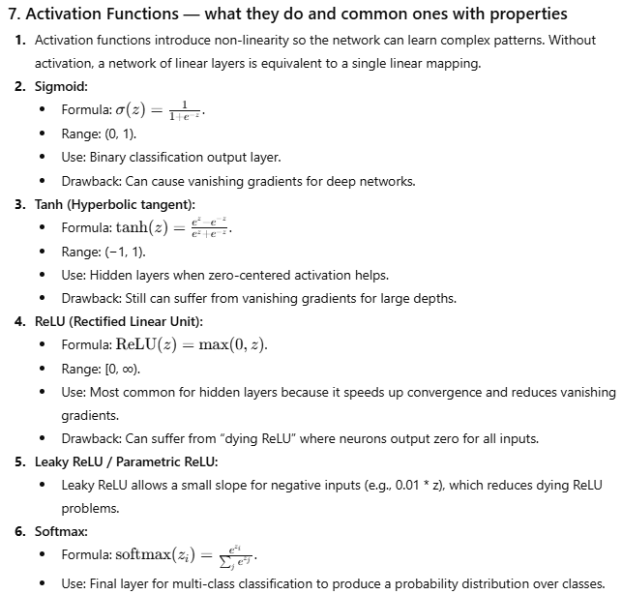
8. Regularization Techniques Commonly Used with ANNs
- L2 Regularization (Weight Decay): Adds a penalty proportional to the square of weights to the loss, discouraging large weights and reducing overfitting.
- L1 Regularization: Adds penalty proportional to absolute weight values, encouraging sparsity.
- Dropout: Randomly disables a fraction of neurons during training to force the network to be robust and reduce co-adaptation.
- Batch Normalization: Normalizes layer inputs to stabilize and accelerate training; it can have a small regularizing effect.

9. Training Process — concise flow
- Initialize weights and biases, usually randomly or with a specific scheme.
- For each training epoch, perform forward propagation to compute outputs.
- Compute the loss using an appropriate loss function.
- Backpropagate the loss to compute gradients for each weight.
- Use an optimizer (e.g., Adam) to update the weights.
- Optionally apply regularization and monitor validation metrics to avoid overfitting.
- Repeat until convergence or until a stopping criterion is met.

10. Exam-Style Short Answers (copy-paste ready)
Q: What is an activation function and why is it needed?
A: An activation function is a nonlinear function applied to a neuron’s input to introduce non-linearity into the network, allowing it to learn complex relationships; without activation functions the network would be equivalent to a single linear model.
Q: Give two common loss functions and where they are used.
A: Mean Squared Error (MSE) is used for regression tasks, and Categorical Cross-Entropy is used for multi-class classification tasks where softmax outputs are used.
Q: Name three optimization algorithms used to train ANNs.
A: Stochastic Gradient Descent (SGD), RMSProp, and Adam are common optimizers used in training neural networks.

Alright cookie, let’s make this super clear, detailed, exam-ready, and still easy to absorb.
Here’s everything cleanly explained.

✅ 1. Parameter Estimation (in ML & Statistics)
Parameter estimation refers to the process of finding the best values of parameters of a probabilistic model using data.
Why do we estimate parameters?
Because the real-world process is unknown — we use data to guess the parameters that MOST likely generated that data.
Examples of parameters:
- Mean (μ) of a Gaussian distribution
- Variance (σ²) of a distribution
- Probability of heads (p) in a coin toss
- Regression weights (θ) in ML models
Goal:
Find parameter values that fit the data well.

✅ 2. Maximum Likelihood Estimation (MLE)
MLE is a method used to estimate parameters by maximizing the likelihood of the observed data.
Meaning of likelihood:
“How likely is the data, given certain parameter values?”
MLE finds the parameter that makes the observed data most probable.
Steps of MLE (generic):
- Assume a probability distribution for the data (e.g., Bernoulli, Gaussian).
- Write the likelihood function ( L(\theta) ).
- Take the log-likelihood to simplify it.
- Differentiate w.r.t. the parameter ( \theta ).
- Set derivative = 0 and solve for ( \theta ).
- The result is the MLE estimate.

✅ 3. MLE Example (Super Simple & Clear)
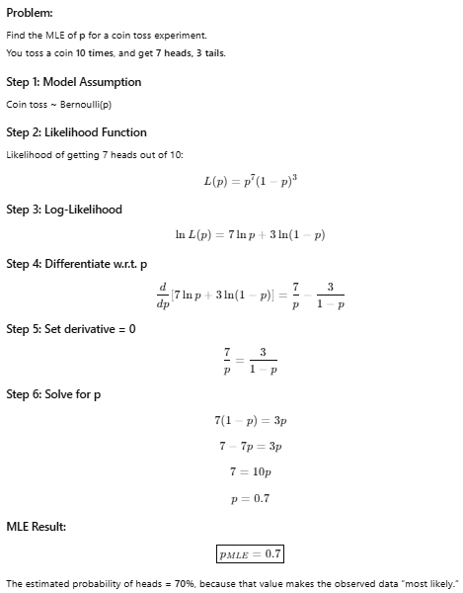

✅ 4. Are Bayesian Estimation and Normal (Frequentist) Estimation Different?
Short Answer:
YES — they are different approaches to estimating parameters.

✅ Frequentist vs Bayesian Parameter Estimation (Tabular Difference)
Point of Difference | Frequentist / Normal Parameter Estimation (MLE) | Bayesian Parameter Estimation
View of Parameters | Parameters are fixed but unknown. | Parameters are random variables with distributions.
Uses Prior Knowledge? | ❌ No prior beliefs used. | ✔️ Uses prior distribution (beliefs before data).
Based On | Likelihood of observing the data. | Prior × Likelihood = Posterior.
Output Type | Point estimate (single best value). | Posterior distribution (range of plausible values).
Main Goal | Find parameters that maximize likelihood (MLE). | Update prior belief using data to form posterior.
Interpretation | “Data alone determines the estimate.” | “Beliefs + data together determine the estimate.”
Computation | Usually simpler and faster. | Can be computationally heavy (needs integration).
Uncertainty Handling | Limited (often uses confidence intervals). | Natural handling through posterior distribution.
Example | Estimate p of coin: p̂ = 0.7 from 7 heads. | Prior belief + 7 heads → updated posterior distribution.

